

**Product Dissection for Paytm**

**Company Overview:**

Paytm (Pay Through Mobile) is an Indian [multinational](https://en.wikipedia.org/wiki/Multinational_corporation) [financial technology company](https://en.wikipedia.org/wiki/Fintech) specializing in digital payments and financial services based in [Noida](https://en.wikipedia.org/wiki/Noida). It was founded in 2010 by [Vijay Shekhar Sharma](https://en.wikipedia.org/wiki/Vijay_Shekhar_Sharma) under [One97 Communications](https://en.wikipedia.org/wiki/One97_Communications). The company offers [mobile payment](https://en.wikipedia.org/wiki/Mobile_payment) services to consumers. It enables merchants to receive payments through its [QR code](https://en.wikipedia.org/wiki/QR_code_payment), Payment Soundbox, Android-based point-of-sale machine, and online [payment gateway](https://en.wikipedia.org/wiki/Payment_gateway) offerings. Apart from [bill payments](https://en.wikipedia.org/wiki/E-commerce_payment_system) and [money](https://en.wikipedia.org/wiki/Instant_payment) transfers, the company also provides [ticketing](https://en.wikipedia.org/wiki/Electronic_ticket) services, [retail brokerage](https://en.wikipedia.org/wiki/Retail_brokerage) products, and [online games](https://en.wikipedia.org/wiki/Online_game).

**Product Dissection and Real-World Problem Solved by Paytm:**

Paytm, a versatile and innovative digital payment and financial services platform, has adeptly addressed real-world challenges through its array of product offerings. With a strong focus on making financial transactions and services accessible to all, Paytm has bridged the gap between traditional financial systems and modern digital convenience. By offering services such as mobile recharges, bill payments, e-commerce, and even digital banking, Paytm has provided a solution to the need for convenient and secure digital financial transactions.

Paytm's ingenious digital payment features, including the Paytm Wallet and Paytm Payments Bank, have revolutionized the way people in India manage their money. These products address challenges such as limited access to banking services and dependence on physical cash. They empower users to easily store, transfer, and manage their finances, bringing financial inclusion to those in remote areas and transforming the way people interact with money.

Paytm's engagement with businesses and merchants through "Paytm for Business" has also addressed real-world challenges. It simplifies digital payment acceptance for small and large businesses, reducing the need for cash transactions and enhancing security.

In addition, Paytm's introduction of a range of services like Paytm Mall, Paytm Gold, and Paytm Postpaid offers practical solutions to everyday financial and shopping needs. For example, Paytm Mall provides a platform for online shopping, addressing the challenge of limited e-commerce access. Paytm Gold allows users to invest in gold digitally, offering an accessible way to invest in a valuable asset.

Overall, Paytm's product design has effectively addressed real-world problems related to digital payments, access to banking services, financial inclusion, and the need for convenience and security in financial transactions. Paytm has played a transformative role in shaping the digital financial landscape and providing practical solutions to the evolving needs of its user base in India.

**Case Study: Real-World Problems and Paytm's Innovative Solutions**

Paytm, a pioneering digital payment and financial services platform, has not only revolutionized the way financial transactions are conducted but has also addressed significant real-world challenges through its innovative features. By identifying user needs and leveraging technology, Paytm has positioned itself as a solution-driven platform that promotes financial inclusion enhances convenience, and transforms the digital financial landscape.

**Problem 1: Cash Dependency**

**Real-World Challenge:** India has traditionally been a cash-centric economy, with many people relying heavily on physical currency for transactions, leading to cash availability and security challenges.

**Paytm's Solution:**

Paytm recognized the need to reduce cash dependency and introduced the Paytm Wallet. Users can securely store money digitally, reducing the need for physical cash. This innovative solution empowers users to make a wide range of digital transactions, including mobile recharges, bill payments, and online shopping. Paytm's Wallet effectively addresses the problem of cash dependency and enhances financial convenience.

**Problem 2: Limited Access to Banking Services**

**Real-World Challenge:** Access to banking services can be limited, especially in rural and underserved areas. Many people face challenges in opening and maintaining traditional bank accounts.

**Paytm's Solution:**

Paytm Payments Bank was introduced to address the issue of limited access to banking services. It offers users the ability to open savings and current accounts digitally, along with features such as debit cards and digital passbooks. This innovation promotes financial inclusion by providing convenient and accessible banking services, effectively solving the problem of limited access to traditional banks.

**Problem 3: Digital Payment Acceptance for Businesses**

**Real-World Challenge:** Small and large businesses often face challenges related to accepting digital payments, which are becoming increasingly important in a digital economy.

**Paytm's Solution:**

Paytm for Business offers a range of solutions for merchants, including QR code-based payments and point-of-sale (POS) systems. This makes it easy for businesses to accept digital payments, reducing the reliance on cash transactions and enhancing payment security. Paytm for Business effectively addresses the problem of digital payment acceptance for businesses.

**Problem 4: Investment in Gold**

**Real-World Challenge:** Many individuals aspire to invest in gold as a valuable asset but face challenges related to physical storage and accessibility.

**Paytm's Solution:**

Paytm Gold allows users to invest in gold digitally. Users can buy and store gold securely in digital form, eliminating the need for physical storage. This innovative solution addresses the problem of investing in gold by providing a convenient and accessible way to do so.

**Conclusion:**

Paytm's journey from a digital payment app to a comprehensive financial services platform is a testament to its ability to identify and address real-world problems through innovation. By reducing cash dependency, promoting financial inclusion, simplifying digital payment acceptance for businesses, and offering accessible investment opportunities, Paytm has effectively solved various challenges users face in the financial domain. This case study showcases how Paytm's user-centric approach and continuous innovation have transformed the way financial transactions and services are conducted, enhancing convenience and financial accessibility for users in India.

**Top Features of Paytm:**

**1. Digital Wallet:** Paytm's digital wallet feature enables users to store and manage their money digitally. This wallet allows for quick and secure payments, making financial transactions more convenient.

**2. Payments Bank:** Paytm Payments Bank offers a range of banking services, including savings accounts, current accounts, and digital banking solutions. It provides users with access to banking services, blurring the lines between traditional and digital banking.

**3. Mobile Recharges:** Users can easily recharge their mobile phones and pay their bills through the Paytm platform. This feature ensures that users stay connected and manage their bills effortlessly.

**4. Bill Payments:** Paytm allows users to pay utility bills, including electricity, water, gas, and more, all in one place. This feature simplifies bill management and ensures timely payments.

**5. E-Commerce Platform:** Paytm Mall offers a comprehensive e-commerce platform where users can shop for a wide range of products, from electronics to fashion. It provides access to online shopping, bringing convenience to users' fingertips.

**6. Paytm for Business:** This feature empowers businesses to accept digital payments from customers. It includes QR code-based payments, making transactions secure and efficient for merchants.

**7. Travel Bookings:** Users can book travel tickets for flights, trains, buses, and more through Paytm. This feature streamlines the travel booking process, offering convenience and often providing discounts.

**8. Digital Gold Investment:** Paytm Gold enables users to invest in gold digitally, eliminating the need for physical storage. It offers a practical solution for those looking to invest in this valuable asset.

**9. Paytm Postpaid:** Users can avail themselves of a line of credit through Paytm Postpaid, making it easier to manage short-term financial needs and facilitating hassle-free transactions.

**10. Paytm Money:** Paytm Money provides a platform for users to invest in mutual funds and manage their portfolios, simplifying the investment process.

**11. Insurance:** Paytm Insurance offers various insurance products, allowing users to secure their financial well-being and protect against unexpected events.

**12. Personalized Profile:** Paytm offers a comprehensive user profile where individuals can express their interests, update profile pictures, and customize their personal information, enhancing personal branding.

In conclusion, Paytm's features cover a wide spectrum of financial services and e-commerce, providing users with the convenience of managing their finances, shopping online, and making secure digital transactions. The platform's diverse set of features effectively addresses the evolving needs of its users in the digital landscape.

**Schema Description for Paytm Database:**

The schema for Paytm's database involves multiple entities that represent different aspects of the platform. These entities include Users, Wallets, Transactions, Paytm Payments Bank Accounts, Bill Payments,Travel Bookings, Loans, Offers, Insurance and more. Each entity has specific attributes that describe its properties and relationships with other entities.

**User Entity:**

Users are central to the Paytm platform. The user entity contains information about each user:

* **UserID (Primary Key):** A unique identifier for each user.
* **Username:** The chosen username for the user's account.
* **Email:** The user's email address for account-related communication.
* **Full_Name:** The user's full name is displayed on their profile.
* **Mobile_Number:** The user's registered mobile number.
* **Registration_Date:** The date when the user joined Paytm.

**Transaction Entity:**

Transactions represent financial activities on the Paytm platform:

* **TransactionID (Primary Key):** A unique identifier for each transaction.
* **UserID (Foreign Key referencing User Entity):** The user involved in the transaction.
* **Amount:** The amount associated with the transaction.
* **Transaction_Date:** The date and time when the transaction occurred.

**Balance Entity:** Balances represent the financial holdings of users in their Paytm Wallets:

* **BalanceID (Primary Key)**: A unique identifier for each balance.
* **UserID (Foreign Key referencing User Entity):** The user who owns the balance.
* **Wallet_Balance:** The current balance of the wallet.
* **LinkedBankBalance:** The current balance in the Paytm bank account.

**Wallet Entity:**

The digital wallet is a core feature of Paytm:

* **WalletID (Primary Key):** A unique identifier for each digital wallet.
* **BalanceID (Foreign Key referencing Balance Entity):** The user who owns the wallet.
* **Wallet_Balance:** The current balance of the wallet.

**Bill Payment Entity:**

Bill payments capture users' financial transactions for utility bills:

* **BillPaymentID (Primary Key):** A unique identifier for each bill payment.
* **UserID (Foreign Key referencing User Entity):** The user who made the bill payment.
* **Bill_Type:** The type of utility bill (e.g., electricity, water, gas).
* **Amount:** The amount paid for the bill.
* **Payment_Date:** The date when the bill payment was made.

**Linked Bank Entity:**

Paytm Payments Bank offers various banking services:

* **BankID (Primary Key):** A unique identifier for each Paytm Payments Bank account.
* **BalanceID (Foreign Key referencing Balance Entity):** The user who holds the bank account.
* **Account_Type:** The type of bank account (e.g., savings, current).
* **LinkedBankBalance:** The current balance in the bank account.

**Loan Entity:**

Loans and credit card information:

* **LoanID (Primary Key):** A unique identifier for each loan.
* **BillPaymentID (Foreign Key referencing Bill Payment Entity):** The Bill Payments associated with the loan.
* **BankID (Foreign Key referencing Linked Bank Entity):** The Linked Bank associated with the loan.
* **Loan_Type:** The type of financial product (e.g., personal loan, credit card).
* **Due_Balance:** The left loan amount to be paid.

**Insurance Entity:**

Details about insurance policies:

* **InsuranceID (Primary Key):** A unique identifier for each insurance policy.
* **BankID (Foreign Key referencing Linked Bank Entity):** The Bank provided insurance policy.
* **Policy_Type:** The type of insurance (e.g., life, health, auto).
* **Coverage:** The coverage amount and details.
* **Policy_Expiry_Date:** The expiration date of the insurance policy.

This schema description outlines the core entities and their attributes within the Paytm platform. It represents the diverse range of financial services, transactions, and user activities that Paytm encompasses.

**ER Diagram:**

Let's create an ER (Entity-Relationship) diagram that vividly illustrates the relationships and attributes of the entities within the Paytm database schema. This ER diagram will serve as a visual representation, providing a clear depiction of the essential components and connections that define the dynamics of Paytm's data model. By using this diagram, you'll gain a comprehensive understanding of how Paytm manages financial transactions, user accounts, merchant interactions, and more.

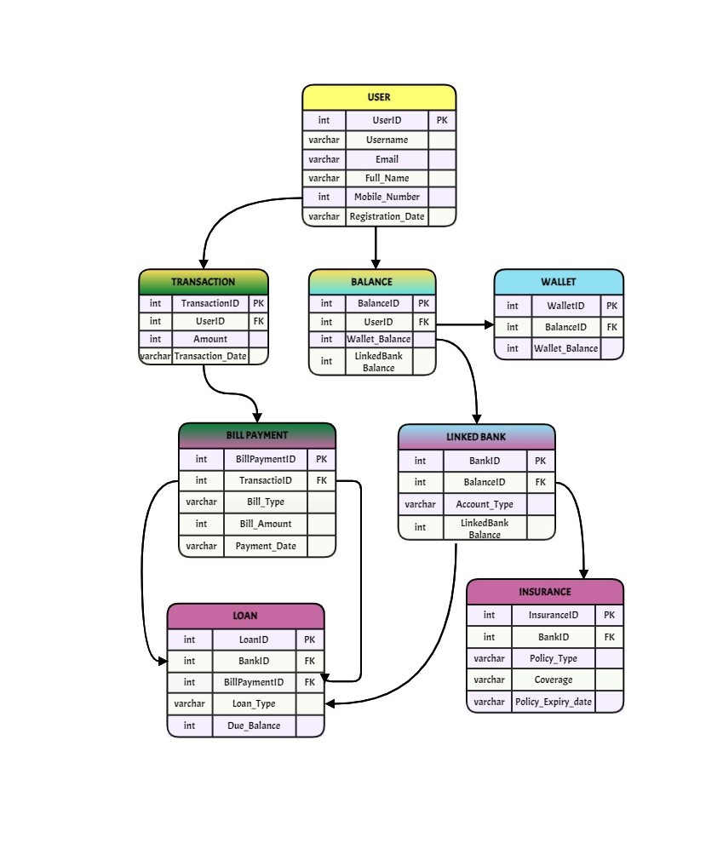**Conclusion:**

In this case study, we explored the design of Paytm's schema and its corresponding Entity-Relationship diagram. Paytm has revolutionized the way people manage their finances and engage in digital transactions, promoting financial inclusion and convenience. The platform's complex data model, comprising entities like users, wallet transactions, payments bank accounts, merchants, orders, products, and relationships, forms the basis for its seamless functionality. By comprehending this schema, we can appreciate how Paytm effectively addresses the intricacies of digital financial services, offering users a secure and user-friendly platform for their financial needs. Paytm's success lies in its ability to bridge the gap between traditional and digital financial systems, making it a leader in the digital payment and financial services domain.

**By: Shiv Prasad Vishwakarma**